Design and Synthesis of CPL-Emissive Helicenes by Controlling Transition Electric and Magnetic Dipole Moments

Kenji Matsuda

Department of Synthetic Chemistry and Biological Chemistry, Graduate School of Engineering,
Kyoto University, Katsura, Nishikyo-ku, Kyoto 615-8510, Japan
Email: kmatsuda@sbchem.kyoto-u.ac.jp

Helicenes have helically twisted MOs and have attracted attention for their chiroptical properties. Circularly polarized luminescence (CPL)-emissive molecular materials with high emission quantum yield (Φ) and high dissymmetry factor (g_{lum}) are desired.
Unsubstituted [5]helicene 1 is non-emissive, however, the fluorescence of [5]helicene derivative 2 is efficiently increased by making the S₁→S₀ transition symmetry-allowed to exhibit a high fluorescence quantum yield (Φ_{f} = 0.23).¹ Synthesis and chiroptical property of [7]helicene derivatives 3² and donor-acceptor type [5]helicene derivative 4³ will also be presented.
Dissymmetry factor (g_{lum}) of CPL is determined by the transition electric and magnetic dipole moments, μ and m, according to the following equation.
··· (1)
D₂ symmetry is the only point group where the direction of μ and m are always parallel, so that high g value is expected. Figure-eight-shaped [5]helicene dimer 5 was thus designed and synthesized to showed excellent chiroptical properties (Φ_{f} = 0.08, |g_{lum}| = 1.5 × 10⁻²) (Fig. 1).⁴

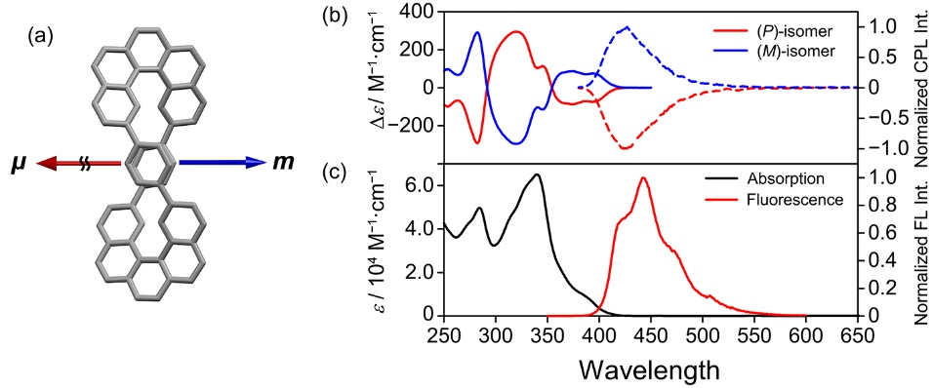
Fig. 1. (a) The spatial arrangement of μ and m of 5. (b) CD (solid line) and CPL (dashed line) spectra of 5 in chloroform at room temperature. (c) UV–vis absorption (left, black line) and fluorescence spectra (right, red line) of 5 in chloroform.

References
[1] H. Kubo, T. Hirose, K. Matsuda, Org. Lett. 2017, 19, 1776−1779.
[2] H. Kubo, T. Hirose, T. Nakashima, T. Kawai, J.-y. Hasegawa, K. Matsuda, J. Phys. Chem. Lett. 2021, 12, 686−695.
[3] H. Kubo, T. Hirose, D. Shimizu, K. Matsuda, Chem. Lett. 2021, 50, 804−807. (Editor's Choice)
[4] H. Kubo, D. Shimizu, T. Hirose, K. Matsuda, Org. Lett. 2020, 22, 9276−9281.

